## National University of Computer and Emerging Sciences

## Theory of Automata(Section A,B,C,D,E)

## Fall2012: Mid 1

**2/Oct/2012**

**Time: 1:30 Hrs Total Marks: 50**

**Problem 1** [20 points]

## i) Give the state diagram for a DFA which recognizes the following language:

$$L=\left\{ω∈{\left\{a,b\right\}}^{*}\right|ω does not contain ab or bba as a substring\}$$

**ii)**In the C programming language, all the following expressions represent valid numerals:

3 13. .328 41.16 +45.80

+0 -01 -14.4 1e12 +1.4e6

-2.e+7 01E-06 0.2E-20 -.4E-7 00e0

Either ‘e’ or ‘E’ refers to an exponent, and if it appears the number following it is an integer. Based on these examples, design an NFA representing the language of numerals in C.

## Problem 2 [2+6+2 points]

## Draw DFA from the transition table given below.

|  |  |  |
| --- | --- | --- |
|  | a | b |
| 1 (Initial) | 2 | 3 |
| 2 | 4 | 3 |
| 3 | 5 | 2 |
| 4 (Final) | 5 | 3 |
| 5 (Final) | 4 | 2 |

## Apply the minimization algorithm to convert the above DFA into its minimized form.

## On what basis minimization algorithm merge multiple states? (Do not explain minimization algorithm)

## 

## Continued…

## Problem 3 [10 points]

Convert the following NFA-^ to DFA to accept the same language. (e (epsilon) represents ^ (lamda))

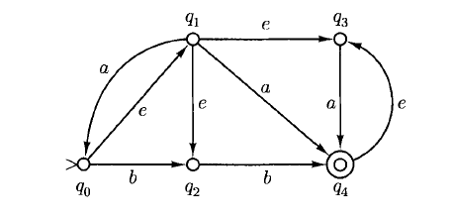

**Problem 4** [10 points]

1. When constructing a DFA from NFA consisting of n states, in the worst-case scenario, what is the maximum number of states can a resulting DFA have?
2. Consider the two regular expressions,

*p* = 0* + 11*

*q* = 01* + 01* + 1*0 + (0*1*)*

Find a string corresponding to *q* but not to *p*(if any).

1. Given this Regular expression: (a+ba*b)*(ba*)define its language in words.
2. Assume that *r*, s and *t* represent regular expressions over the alphabet {0,1}. Then ( *r* +*s+ t* )* and *r*\**s*\*t* represent the same language. If the statement is true, justify it else give a counter example.